Briefly describe about AI
Sure. I’ll create a brief, clear Word document explaining Artificial Intelligence (AI), including its meaning, applications, benefits, limitations, and future.
Artificial Intelligence
Meaning of AI
Artificial Intelligence (AI) is a technology that enables computers and machines to perform tasks that normally require human intelligence. These tasks include learning, reasoning, understanding language, recognizing images, solving problems, and making decisions.
Applications of AI
AI is used in many areas, including healthcare, education, banking and finance, transportation, manufacturing, agriculture, customer service, cybersecurity, entertainment, and scientific research. Examples include virtual assistants, recommendation systems, medical image analysis, fraud detection, and autonomous systems.
Benefits of AI
AI can automate repetitive tasks, improve productivity, analyze large amounts of data quickly, support better decision-making, reduce human error in suitable tasks, provide personalized services, and operate continuously. It can also help researchers and professionals solve complex problems.
Limitations of AI
AI systems depend on the quality of their data and design. They can produce inaccurate or biased results, may lack human judgment and common sense, require computing resources and maintenance, and can create privacy, security, employment, and ethical concerns when used improperly.
Future of AI
The future of AI is expected to involve more capable and useful systems that work alongside people. AI may contribute to advances in medicine, education, science, business, robotics, and accessibility. Responsible development, human oversight, privacy protection, security, and appropriate regulation will remain important as AI becomes more widely used.
The Human intelligence(image) having a heartbeat is to interact with AI image to give result’s butterfly .It happens when both sun and moon rays both at a time falls on particular girl(all woman living on earth having a heartbeat as described it is depend on AI image to collect data from man and use a interactive device gadget(model T4*5g) to create a new insect called butterfly.
Ref:Img: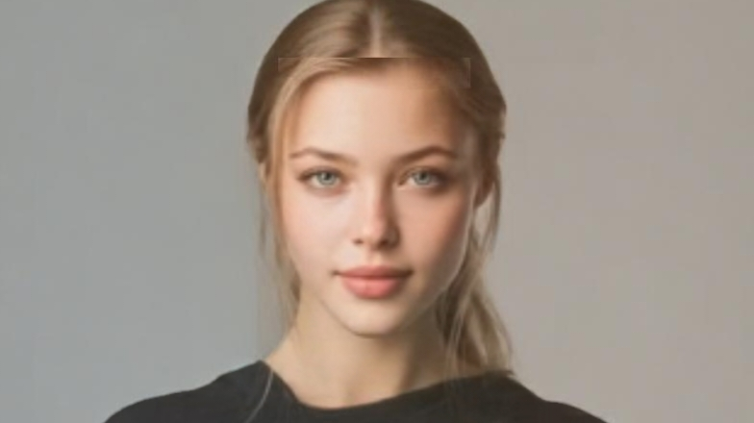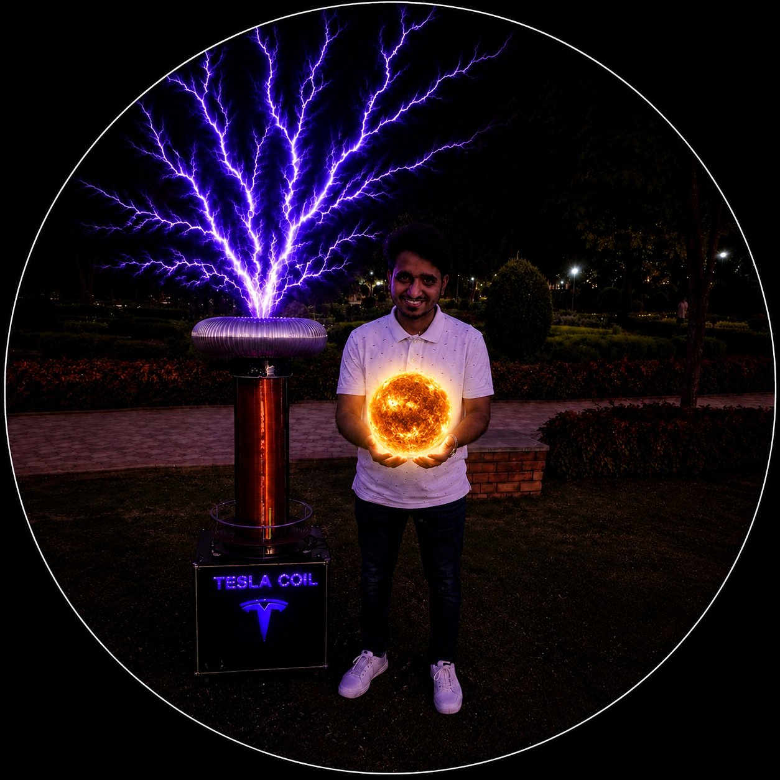
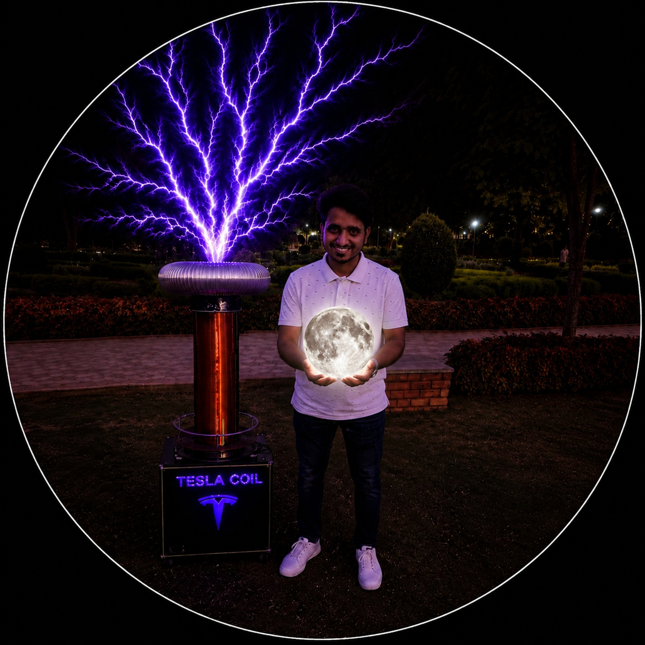
(To get best quality output gg_image is used)

Human heartbeat synchronized with sun core and AC/DC motor array — upload a person's image to detect BPM and drive the solar-motor system

HTML Program with visual studio

<style>
*{box-sizing:border-box;margin:0;padding:0}
:root{
--sol-gold:#BA7517;--sol-amber:#EF9F27;--sol-hot:#E24B4A;
--sol-core:#FAC775;--sol-corona:#FAEEDA;
--ac-blue:#185FA5;--dc-green:#3B6D11;
--heart-red:#A32D2D;
}
body{font-family:var(--font-sans)}
.root{padding:1rem 0 2rem}
.top-bar{display:grid;grid-template-columns:1fr 1fr;gap:10px;margin-bottom:12px}
.card{background:var(--color-background-primary);border:0.5px solid var(--color-border-tertiary);border-radius:var(--border-radius-lg);padding:1rem 1.25rem}
.lbl{font-size:11px;font-weight:500;color:var(--color-text-secondary);text-transform:uppercase;letter-spacing:.06em;margin-bottom:8px}
.input-row{display:flex;gap:6px}
.input-row input{flex:1;font-size:13px}
.upload-wrap{position:relative;flex-shrink:0}
.upload-wrap input[type=file]{position:absolute;inset:0;opacity:0;cursor:pointer}
.thumb{width:100%;height:90px;object-fit:cover;border-radius:8px;border:0.5px solid var(--color-border-tertiary);margin-top:8px;display:none}
.remove-btn{position:absolute;top:10px;right:6px;background:var(--color-background-primary);border:0.5px solid var(--color-border-secondary);border-radius:50%;width:20px;height:20px;display:none;align-items:center;justify-content:center;cursor:pointer;font-size:11px;color:var(--color-text-secondary);z-index:2}
.bpm-hero{text-align:center;padding:4px 0}
.bpm-num{font-size:44px;font-weight:500;line-height:1;color:var(--color-text-primary)}
.bpm-sub{font-size:12px;color:var(--color-text-secondary);margin-top:2px}
.bpm-tag{display:inline-block;margin-top:6px;font-size:11px;padding:2px 10px;border-radius:20px;font-weight:500;background:var(--color-background-success);color:var(--color-text-success)}
.bpm-tag.warn{background:var(--color-background-warning);color:var(--color-text-warning)}
.bpm-tag.danger{background:var(--color-background-danger);color:var(--color-text-danger)}

.main-viz{position:relative;margin-bottom:12px;border-radius:var(--border-radius-lg);overflow:hidden;border:0.5px solid var(--color-border-tertiary)}
#mainCanvas{display:block;width:100%;height:auto}

.motor-row{display:grid;grid-template-columns:1fr 1fr;gap:10px;margin-bottom:12px}
.motor-card{background:var(--color-background-primary);border:0.5px solid var(--color-border-tertiary);border-radius:var(--border-radius-lg);padding:.875rem 1rem}
.motor-header{display:flex;align-items:center;justify-content:space-between;margin-bottom:10px}
.motor-title{font-size:13px;font-weight:500;color:var(--color-text-primary)}
.motor-badge{font-size:10px;padding:2px 8px;border-radius:10px;font-weight:500}
.badge-ac{background:var(--color-background-info);color:var(--color-text-info)}
.badge-dc{background:var(--color-background-success);color:var(--color-text-success)}
.motor-canvas-wrap{position:relative;height:120px;background:var(--color-background-secondary);border-radius:8px;overflow:hidden;margin-bottom:8px}
.motor-stat-row{display:grid;grid-template-columns:1fr 1fr;gap:6px}
.mstat{background:var(--color-background-secondary);border-radius:6px;padding:6px 8px;text-align:center}
.mstat-v{font-size:14px;font-weight:500;color:var(--color-text-primary)}
.mstat-l{font-size:10px;color:var(--color-text-secondary);margin-top:1px}

.solar-panel{background:var(--color-background-primary);border:0.5px solid var(--color-border-tertiary);border-radius:var(--border-radius-lg);padding:1rem 1.25rem;margin-bottom:12px}
.solar-grid{display:grid;grid-template-columns:repeat(4,1fr);gap:8px;margin-top:8px}
.sol-stat{background:var(--color-background-secondary);border-radius:8px;padding:8px;text-align:center}
.sol-v{font-size:15px;font-weight:500;color:var(--color-text-primary)}
.sol-l{font-size:10px;color:var(--color-text-secondary);margin-top:2px}

.ctrl-row{display:flex;gap:8px;align-items:center;margin-bottom:10px}
#startBtn{flex:1;padding:10px;font-size:14px;font-weight:500;border-radius:10px;border:0.5px solid var(--color-border-secondary);background:var(--color-background-primary);cursor:pointer;color:var(--color-text-primary);display:flex;align-items:center;justify-content:center;gap:8px;transition:all .15s}
#startBtn.on{background:var(--color-background-danger);color:var(--color-text-danger);border-color:var(--color-border-danger)}
#analyzeBtn{padding:10px 14px;font-size:13px;border-radius:10px;border:0.5px solid var(--color-border-secondary);background:var(--color-background-secondary);cursor:pointer;color:var(--color-text-secondary);white-space:nowrap;display:flex;align-items:center;gap:6px}
#boostBtn{padding:10px 14px;font-size:13px;border-radius:10px;border:0.5px solid var(--color-border-secondary);background:var(--color-background-warning);cursor:pointer;color:var(--color-text-warning);font-weight:500;white-space:nowrap}

.ecg-row{background:var(--color-background-secondary);border-radius:8px;overflow:hidden;height:50px;margin-bottom:10px}
#ecgCanvas{width:100%;height:50px;display:block}

.log-box{background:var(--color-background-secondary);border-radius:8px;padding:10px;font-size:11px;font-family:var(--font-mono);max-height:72px;overflow-y:auto;line-height:1.7}
.log-box .ok{color:var(--color-text-success)}
.log-box .info{color:var(--color-text-info)}
.log-box .err{color:var(--color-text-danger)}
.log-box .warn{color:var(--color-text-warning)}

.overlay-wrap{position:absolute;inset:0;background:rgba(0,0,0,.4);display:none;align-items:center;justify-content:center;border-radius:var(--border-radius-lg);flex-direction:column;gap:8px;z-index:10}
.overlay-wrap.show{display:flex}
.spinner{width:26px;height:26px;border:3px solid rgba(255,255,255,.3);border-top-color:#fff;border-radius:50%;animation:spin .7s linear infinite}
@keyframes spin{to{transform:rotate(360deg)}}
.overlay-wrap p{color:#fff;font-size:13px;font-weight:500}

.pulse-dot{width:10px;height:10px;border-radius:50%;background:var(--color-text-danger);display:inline-block;animation:throb 1s ease-in-out infinite}
@keyframes throb{0%,100%{transform:scale(1)}50%{transform:scale(1.5)}}
</style>

<h2 class="sr-only">Human heartbeat synchronized with sun core and AC/DC motor array — upload a person's image to detect BPM and drive the solar-motor system</h2>

<div class="root">

<div class="top-bar">
<div class="card" style="position:relative">
<div class="lbl">Person — image or URL</div>
<div class="input-row">
<input type="text" id="urlIn" placeholder="Paste image URL…" />
<div class="upload-wrap">
<input type="file" id="fileIn" accept="image/*" />
<button style="height:34px;padding:0 10px;font-size:12px"><i class="ti ti-upload" aria-hidden="true"></i></button>
</div>
</div>
<div style="position:relative">
<img id="thumb" class="thumb" alt="Person"/>
<div class="remove-btn" id="rmBtn" onclick="removeImg()"><i class="ti ti-x"></i></div>
</div>
<div class="overlay-wrap" id="aiOverlay">
<div class="spinner"></div>
<p id="aiMsg">Analyzing…</p>
</div>
</div>

<div class="card">
<div class="lbl">Heart rate</div>
<div class="bpm-hero">
<div class="bpm-num" id="bpmNum">--</div>
<div class="bpm-sub">beats per minute <span class="pulse-dot" id="pulseDot" style="display:none"></span></div>
<div class="bpm-tag" id="bpmTag" style="visibility:hidden">Normal</div>
</div>
</div>
</div>

<div class="main-viz" id="mainVizWrap">
<canvas id="mainCanvas" width="660" height="320"></canvas>
</div>

<div class="motor-row">
<div class="motor-card">
<div class="motor-header">
<span class="motor-title"><i class="ti ti-bolt" aria-hidden="true" style="font-size:14px"></i> AC induction motor</span>
<span class="motor-badge badge-ac">3-phase</span>
</div>
<div class="motor-canvas-wrap">
<canvas id="acCanvas" width="280" height="120" style="width:100%;height:100%"></canvas>
</div>
<div class="motor-stat-row">
<div class="mstat"><div class="mstat-v" id="acRpm">0</div><div class="mstat-l">RPM</div></div>
<div class="mstat"><div class="mstat-v" id="acFreq">0 Hz</div><div class="mstat-l">Frequency</div></div>
<div class="mstat"><div class="mstat-v" id="acTorque">0 Nm</div><div class="mstat-l">Torque</div></div>
<div class="mstat"><div class="mstat-v" id="acEff">0%</div><div class="mstat-l">Efficiency</div></div>
</div>
</div>

<div class="motor-card">
<div class="motor-header">
<span class="motor-title"><i class="ti ti-current-dc" aria-hidden="true" style="font-size:14px"></i> DC brushless motor</span>
<span class="motor-badge badge-dc">PWM</span>
</div>
<div class="motor-canvas-wrap">
<canvas id="dcCanvas" width="280" height="120" style="width:100%;height:100%"></canvas>
</div>
<div class="motor-stat-row">
<div class="mstat"><div class="mstat-v" id="dcRpm">0</div><div class="mstat-l">RPM</div></div>
<div class="mstat"><div class="mstat-v" id="dcDuty">0%</div><div class="mstat-l">PWM duty</div></div>
<div class="mstat"><div class="mstat-v" id="dcPower">0 W</div><div class="mstat-l">Power</div></div>
<div class="mstat"><div class="mstat-v" id="dcEff">0%</div><div class="mstat-l">Efficiency</div></div>
</div>
</div>
</div>

<div class="solar-panel">
<div class="lbl"><i class="ti ti-sun" aria-hidden="true" style="font-size:13px"></i> Solar core output — synchronized to heartbeat</div>
<div class="solar-grid">
<div class="sol-stat"><div class="sol-v" id="solTemp">0 MK</div><div class="sol-l">Core temp</div></div>
<div class="sol-stat"><div class="sol-v" id="solLum">0%</div><div class="sol-l">Luminosity</div></div>
<div class="sol-stat"><div class="sol-v" id="solPlasma">0 kG</div><div class="sol-l">Plasma field</div></div>
<div class="sol-stat"><div class="sol-v" id="solFusion">0 TW</div><div class="sol-l">Fusion output</div></div>
</div>
</div>

<div class="ctrl-row">
<button id="startBtn" onclick="toggleSystem()">
<i class="ti ti-player-play" id="playIcon" aria-hidden="true"></i>
<span id="startLabel">Start system</span>
</button>
<button id="analyzeBtn" onclick="analyzeImage()">
<i class="ti ti-heart-rate-monitor" aria-hidden="true"></i> Detect BPM
</button>
<button id="boostBtn" onclick="solarBoost()">
<i class="ti ti-flame" aria-hidden="true"></i> Solar burst
</button>
</div>

<div class="ecg-row"><canvas id="ecgCanvas"></canvas></div>
<div class="log-box" id="logBox"><div class="info">[system] Ready — upload a person's image and click Detect BPM to begin.</div></div>
</div>

<script>
let bpm=0,running=false,angle=0,acAngle=0,dcAngle=0;
let ecgPts=[],ecgPhase=0;
let solarBoostActive=false,solarBoostT=0;
let imgBase64=null,imgUrl=null;
let raf=null;
let lastStats=0;

const mainC=document.getElementById('mainCanvas');
const mCtx=mainC.getContext('2d');
const acC=document.getElementById('acCanvas');
const acCtx=acC.getContext('2d');
const dcC=document.getElementById('dcCanvas');
const dcCtx=dcC.getContext('2d');
const ecgC=document.getElementById('ecgCanvas');
const eCtx=ecgC.getContext('2d');

function resizeEcg(){ecgC.width=ecgC.parentElement.clientWidth;ecgC.height=50;}
resizeEcg();
window.addEventListener('resize',resizeEcg);

function isDark(){return window.matchMedia('(prefers-color-scheme: dark)').matches;}

function log(msg,cls=''){
const b=document.getElementById('logBox');
const t=new Date().toLocaleTimeString([],{hour:'2-digit',minute:'2-digit',second:'2-digit'});
const d=document.createElement('div');
if(cls)d.className=cls;
d.textContent=`[${t}] ${msg}`;
b.appendChild(d);
b.scrollTop=b.scrollHeight;
}

document.getElementById('fileIn').addEventListener('change',function(e){
const f=e.target.files[0];if(!f)return;
const r=new FileReader();
r.onload=ev=>{
imgBase64=ev.target.result.split(',')[1];
imgUrl=null;
const th=document.getElementById('thumb');
th.src=ev.target.result;th.style.display='block';
document.getElementById('rmBtn').style.display='flex';
log('Image loaded from file.','ok');
};
r.readAsDataURL(f);
});

document.getElementById('urlIn').addEventListener('change',function(){
const u=this.value.trim();if(!u)return;
imgUrl=u;imgBase64=null;
const th=document.getElementById('thumb');
th.src=u;th.style.display='block';
document.getElementById('rmBtn').style.display='flex';
log('Image URL set.','ok');
});

function removeImg(){
imgBase64=null;imgUrl=null;
document.getElementById('thumb').style.display='none';
document.getElementById('thumb').src='';
document.getElementById('rmBtn').style.display='none';
document.getElementById('urlIn').value='';
document.getElementById('fileIn').value='';
log('Image removed.','');
}

async function analyzeImage(){
if(!imgBase64&&!imgUrl){log('No image provided.','err');return;}
const ov=document.getElementById('aiOverlay');
const ms=document.getElementById('aiMsg');
ov.classList.add('show');ms.textContent='Sending to Claude AI…';
log('Analyzing image with Claude vision…','info');
let imgContent;
if(imgBase64){
const src=document.getElementById('thumb').src;
let mt='image/jpeg';
if(src.includes('data:image/png'))mt='image/png';
else if(src.includes('data:image/webp'))mt='image/webp';
imgContent={type:'image',source:{type:'base64',media_type:mt,data:imgBase64}};
} else {
imgContent={type:'image',source:{type:'url',url:imgUrl}};
}
try{
ms.textContent='AI detecting vitals…';
const resp=await fetch('https://api.anthropic.com/v1/messages',{
method:'POST',
headers:{'Content-Type':'application/json'},
body:JSON.stringify({
model:'claude-sonnet-4-6',max_tokens:1000,
messages:[{role:'user',content:[
imgContent,
{type:'text',text:`Analyze this person's image and estimate their resting heart rate using all visible cues: apparent age, fitness, complexion, expression, posture, body composition.

Return ONLY valid JSON, no markdown, no extra text:
{
"bpm": <integer 40-160>,
"confidence": "<low|medium|high>",
"age_range": "<e.g. 25-35>",
"fitness": "<sedentary|average|athletic>",
"skin_tone": "<description>",
"solar_resonance": "<brief metaphorical link between this person's energy and solar output>",
"reason": "<one sentence>"
}`}
]}]
})
});
if(!resp.ok)throw new Error('API '+resp.status);
const data=await resp.json();
const txt=data.content.map(c=>c.text||'').join('');
const clean=txt.replace(/```json|```/g,'').trim();
const p=JSON.parse(clean);
setBpm(p.bpm);
log(`BPM: ${p.bpm} (${p.confidence} confidence) — ${p.reason}`,'ok');
log(`Solar resonance: ${p.solar_resonance}`,'warn');
log(`Age: ${p.age_range} | Fitness: ${p.fitness}`,'info');
}catch(e){
log('AI analysis error: '+e.message,'err');
const fb=Math.round(62+Math.random()*26);
setBpm(fb);
log(`Fallback BPM estimate: ${fb}`,'info');
}finally{ov.classList.remove('show');}
}

function setBpm(v){
bpm=v;
document.getElementById('bpmNum').textContent=v;
const tag=document.getElementById('bpmTag');
tag.style.visibility='visible';
if(v<60){tag.textContent='Bradycardia';tag.className='bpm-tag warn';}
else if(v<=100){tag.textContent='Normal sinus';tag.className='bpm-tag';}
else{tag.textContent='Tachycardia';tag.className='bpm-tag danger';}
}

function toggleSystem(){
if(bpm===0&&!running){log('No BPM detected. Click Detect BPM first.','err');return;}
running=!running;
const btn=document.getElementById('startBtn');
const ico=document.getElementById('playIcon');
const lbl=document.getElementById('startLabel');
document.getElementById('pulseDot').style.display=running?'inline-block':'none';
if(running){
btn.classList.add('on');ico.className='ti ti-player-stop';lbl.textContent='Stop system';
log(`System started — ${bpm} BPM → Solar core + AC/DC motors synced.`,'ok');
loop();
} else {
btn.classList.remove('on');ico.className='ti ti-player-play';lbl.textContent='Start system';
log('System stopped.','');
if(raf)cancelAnimationFrame(raf);raf=null;
clearCanvases();
}
}

function solarBoost(){
if(!running){log('Start the system first.','err');return;}
solarBoostActive=true;solarBoostT=0;
log('Solar burst activated — plasma ejection event!','warn');
}

function clearCanvases(){
mCtx.clearRect(0,0,mainC.width,mainC.height);
acCtx.clearRect(0,0,acC.width,acC.height);
dcCtx.clearRect(0,0,dcC.width,dcC.height);
eCtx.clearRect(0,0,ecgC.width,ecgC.height);
document.getElementById('acRpm').textContent='0';
document.getElementById('acFreq').textContent='0 Hz';
document.getElementById('acTorque').textContent='0 Nm';
document.getElementById('acEff').textContent='0%';
document.getElementById('dcRpm').textContent='0';
document.getElementById('dcDuty').textContent='0%';
document.getElementById('dcPower').textContent='0 W';
document.getElementById('dcEff').textContent='0%';
document.getElementById('solTemp').textContent='0 MK';
document.getElementById('solLum').textContent='0%';
document.getElementById('solPlasma').textContent='0 kG';
document.getElementById('solFusion').textContent='0 TW';
}

function ecgVal(phase){
const t=(phase%(2*Math.PI))/(2*Math.PI);
if(t<0.05)return t/0.05*0.12;
if(t<0.12)return 0.12-(t-0.05)/0.07*0.25;
if(t<0.18)return-0.13+(t-0.12)/0.06*1.15;
if(t<0.22){const p=(t-0.18)/0.04;return 1-p*1.9;}
if(t<0.27){const p=(t-0.22)/0.05;return-0.9+p*1.15;}
if(t<0.33){const p=(t-0.27)/0.06;return 0.25-p*0.25;}
if(t<0.50){const p=(t-0.33)/0.17;return Math.sin(p*Math.PI)*0.38;}
return 0;
}

function loop(){
if(!running)return;
const bpmR=bpm+(solarBoostActive?bpm*0.15:0);
const beatHz=bpmR/60;
const dt=1/60;
const acRPM=bpmR*14;
const dcRPM=bpmR*9;
acAngle=(acAngle+acRPM/60*6*dt*360)%360;
dcAngle=(dcAngle+dcRPM/60*6*dt*360)%360;
ecgPhase+=beatHz*2*Math.PI*dt;

if(solarBoostActive){solarBoostT+=dt;if(solarBoostT>3)solarBoostActive=false;}

const now=Date.now();
ecgPts.push({t:now,v:ecgVal(ecgPhase)});
ecgPts=ecgPts.filter(p=>now-p.t<3500);

drawSun(solarBoostActive,bpmR);
drawACMotor(acAngle,bpmR);
drawDCMotor(dcAngle,bpmR);
drawECG();

if(now-lastStats>400){
lastStats=now;
const boost=solarBoostActive?1.18:1;
const acFreq=(acRPM/60*boost).toFixed(1);
const acTq=(1.2+bpmR/200*boost).toFixed(2);
const acE=Math.round(87+Math.random()*4);
document.getElementById('acRpm').textContent=Math.round(acRPM*boost);
document.getElementById('acFreq').textContent=acFreq+' Hz';
document.getElementById('acTorque').textContent=acTq+' Nm';
document.getElementById('acEff').textContent=acE+'%';
const dcDuty=Math.min(99,Math.round(bpmR/200*100*boost));
const dcPow=Math.round(dcRPM*0.12*boost);
const dcE=Math.round(84+Math.random()*5);
document.getElementById('dcRpm').textContent=Math.round(dcRPM*boost);
document.getElementById('dcDuty').textContent=dcDuty+'%';
document.getElementById('dcPower').textContent=dcPow+' W';
document.getElementById('dcEff').textContent=dcE+'%';
const bt=solarBoostActive?solarBoostT/3:0;
const bFactor=1+bt*0.4;
const corT=(15+bpmR/200*7)*bFactor;
const lum=Math.round((40+bpmR/200*55)*bFactor*100)/100;
const plasma=((18+bpmR/200*30)*bFactor).toFixed(1);
const fusion=Math.round((384+bpmR/200*180)*bFactor);
document.getElementById('solTemp').textContent=corT.toFixed(1)+' MK';
document.getElementById('solLum').textContent=lum.toFixed(1)+'%';
document.getElementById('solPlasma').textContent=plasma+' kG';
document.getElementById('solFusion').textContent=fusion+' TW';
}

raf=requestAnimationFrame(loop);
}

function drawSun(boost,bpmR){
const W=mainC.width,H=mainC.height;
mCtx.clearRect(0,0,W,H);
const dark=isDark();
const bgColor=dark?'#1a1510':'#FFF8EE';
mCtx.fillStyle=bgColor;mCtx.fillRect(0,0,W,H);

const cx=W/2,cy=H/2;
const bt=boost?(solarBoostT/3):0;
const bFactor=1+bt*0.3;
const pulseAdd=Math.sin(Date.now()*0.006)*4;

const coronaR=(90+pulseAdd*2)*bFactor;
const rays=12+Math.round(bpmR/20);
for(let i=0;i<rays;i++){
const a=(angle*Math.PI/180)+(i/rays)*Math.PI*2;
const r0=coronaR*0.82,r1=coronaR*(1.05+bt*0.25+Math.sin(i*3+Date.now()*0.002)*0.06);
mCtx.beginPath();
mCtx.moveTo(cx+Math.cos(a)*r0,cy+Math.sin(a)*r0);
mCtx.lineTo(cx+Math.cos(a)*r1,cy+Math.sin(a)*r1);
mCtx.strokeStyle=boost?'#EF9F27':'#FAC775';
mCtx.lineWidth=boost?2.5+bt*1.5:1.5;
mCtx.globalAlpha=0.45+bt*0.3;
mCtx.stroke();
mCtx.globalAlpha=1;
}

mCtx.beginPath();mCtx.arc(cx,cy,coronaR*0.88,0,Math.PI*2);
mCtx.fillStyle=dark?'#EF9F27':'#FAC775';mCtx.fill();

mCtx.beginPath();mCtx.arc(cx,cy,coronaR*0.7,0,Math.PI*2);
mCtx.fillStyle=dark?'#BA7517':'#EF9F27';mCtx.fill();

const flareCount=6+Math.round(bpmR/15);
for(let i=0;i<flareCount;i++){
const fa=(angle*0.7*Math.PI/180)+(i/flareCount)*Math.PI*2;
const fr=coronaR*(0.68+Math.sin(i*7+Date.now()*0.003)*0.08);
mCtx.beginPath();
mCtx.arc(cx+Math.cos(fa)*fr*0.5,cy+Math.sin(fa)*fr*0.5,6+bt*4,0,Math.PI*2);
mCtx.fillStyle=boost?'#E24B4A':'#BA7517';
mCtx.globalAlpha=0.5+bt*0.4;
mCtx.fill();
mCtx.globalAlpha=1;
}

mCtx.beginPath();mCtx.arc(cx,cy,coronaR*0.46,0,Math.PI*2);
mCtx.fillStyle=dark?'#412402':'#FAEEDA';mCtx.fill();

const numFusion=Math.round(3+bpmR/25);
for(let i=0;i<numFusion;i++){
const fa2=((angle*2+i*60)*Math.PI/180);
const fr2=coronaR*(0.12+Math.random()*0.22);
mCtx.beginPath();
mCtx.arc(cx+Math.cos(fa2)*fr2,cy+Math.sin(fa2)*fr2,3+bt*2,0,Math.PI*2);
mCtx.fillStyle='#E24B4A';
mCtx.globalAlpha=0.7+bt*0.3;
mCtx.fill();
mCtx.globalAlpha=1;
}

const fieldLines=8;
for(let i=0;i<fieldLines;i++){
const fa3=(angle*1.5*Math.PI/180)+(i/fieldLines)*Math.PI*2;
const sx=cx+Math.cos(fa3)*coronaR*0.42;
const sy=cy+Math.sin(fa3)*coronaR*0.42;
const ex=cx+Math.cos(fa3+Math.PI/fieldLines)*coronaR*(0.85+bt*0.15);
const ey=cy+Math.sin(fa3+Math.PI/fieldLines)*coronaR*(0.85+bt*0.15);
mCtx.beginPath();
mCtx.moveTo(sx,sy);
mCtx.quadraticCurveTo(cx+Math.cos(fa3+Math.PI/fieldLines/2)*coronaR*(0.6+bt*0.1),cy+Math.sin(fa3+Math.PI/fieldLines/2)*coronaR*(0.6+bt*0.1),ex,ey);
mCtx.strokeStyle=boost?'#E24B4A':'#BA7517';
mCtx.lineWidth=0.8;mCtx.globalAlpha=0.35+bt*0.25;mCtx.stroke();
mCtx.globalAlpha=1;
}

const labelColor=dark?'#FAC775':'#854F0B';
const textColor=dark?'#EF9F27':'#633806';
mCtx.font='500 12px var(--font-sans,sans-serif)';
mCtx.textAlign='center';
mCtx.fillStyle=labelColor;
mCtx.fillText('Solar core',cx,cy+5);
mCtx.font='400 10px var(--font-sans,sans-serif)';
mCtx.fillStyle=textColor;
mCtx.fillText('Fusion zone',cx,cy+18);

mCtx.font='400 10px var(--font-sans,sans-serif)';
mCtx.textAlign='left';
mCtx.fillStyle=dark?'#B4B2A9':'#5F5E5A';
mCtx.fillText('Convection zone',cx+coronaR*0.9+6,cy-20);
mCtx.fillText('Radiative zone',cx+coronaR*0.65+6,cy-6);
mCtx.fillText('Magnetic loops',cx+coronaR*0.5+6,cy+10);

if(boost){
mCtx.font='500 11px var(--font-sans,sans-serif)';
mCtx.fillStyle=dark?'#E24B4A':'#A32D2D';
mCtx.textAlign='center';
mCtx.fillText('SOLAR BURST ACTIVE',cx,H-18);
}

angle=(angle+bpmR/60*3/60*360)%360;
}

function drawACMotor(ang,bpmR){
const W=acC.width,H=acC.height;
acCtx.clearRect(0,0,W,H);
const dark=isDark();
const cx=W/2,cy=H/2;
const r=40;
const bodyFill=dark?'#0C447C':'#E6F1FB';
const strokeC=dark?'#185FA5':'#378ADD';
acCtx.beginPath();acCtx.arc(cx,cy,r,0,Math.PI*2);
acCtx.fillStyle=bodyFill;acCtx.fill();
acCtx.strokeStyle=strokeC;acCtx.lineWidth=1.5;acCtx.stroke();

const phases=3;
const phaseColors=['#E24B4A','#639922','#378ADD'];
for(let i=0;i<phases;i++){
const a=(ang+i*(360/phases))*Math.PI/180;
const x1=cx+Math.cos(a)*r*0.3,y1=cy+Math.sin(a)*r*0.3;
const x2=cx+Math.cos(a)*r*0.82,y2=cy+Math.sin(a)*r*0.82;
acCtx.beginPath();acCtx.moveTo(x1,y1);acCtx.lineTo(x2,y2);
acCtx.strokeStyle=phaseColors[i];acCtx.lineWidth=3;acCtx.stroke();
acCtx.beginPath();acCtx.arc(x2,y2,5,0,Math.PI*2);
acCtx.fillStyle=phaseColors[i];acCtx.fill();
}

acCtx.beginPath();acCtx.arc(cx,cy,8,0,Math.PI*2);
acCtx.fillStyle=dark?'#444441':'#888780';acCtx.fill();
acCtx.beginPath();acCtx.moveTo(cx+r,cy);acCtx.lineTo(cx+r+20,cy);
acCtx.strokeStyle=dark?'#444441':'#888780';acCtx.lineWidth=5;acCtx.stroke();

const numSpin=Math.round(3+bpmR/40);
for(let i=0;i<numSpin;i++){
const a2=(ang*2.5+i*(360/numSpin))*Math.PI/180;
const ax=cx+Math.cos(a2)*(r+12),ay=cy+Math.sin(a2)*(r+12);
acCtx.save();acCtx.translate(ax,ay);acCtx.rotate(a2+Math.PI/2);
acCtx.beginPath();acCtx.moveTo(0,-4);acCtx.lineTo(2.5,2);acCtx.lineTo(-2.5,2);acCtx.closePath();
acCtx.fillStyle=dark?'#85B7EB':'#185FA5';acCtx.globalAlpha=0.6;acCtx.fill();
acCtx.restore();acCtx.globalAlpha=1;
}
}

function drawDCMotor(ang,bpmR){
const W=dcC.width,H=dcC.height;
dcCtx.clearRect(0,0,W,H);
const dark=isDark();
const cx=W/2,cy=H/2;
const r=40;
const bodyFill=dark?'#27500A':'#EAF3DE';
const strokeC=dark?'#3B6D11':'#639922';
dcCtx.beginPath();dcCtx.arc(cx,cy,r,0,Math.PI*2);
dcCtx.fillStyle=bodyFill;dcCtx.fill();
dcCtx.strokeStyle=strokeC;dcCtx.lineWidth=1.5;dcCtx.stroke();

const coils=4;
for(let i=0;i<coils;i++){
const a=(ang+i*(360/coils))*Math.PI/180;
const x1=cx+Math.cos(a)*r*0.28,y1=cy+Math.sin(a)*r*0.28;
const x2=cx+Math.cos(a)*r*0.80,y2=cy+Math.sin(a)*r*0.80;
dcCtx.beginPath();dcCtx.moveTo(x1,y1);dcCtx.lineTo(x2,y2);
dcCtx.strokeStyle=dark?'#97C459':'#3B6D11';dcCtx.lineWidth=2.5;dcCtx.stroke();
dcCtx.beginPath();dcCtx.arc(x2,y2,4,0,Math.PI*2);
dcCtx.fillStyle=dark?'#C0DD97':'#639922';dcCtx.fill();
}

dcCtx.beginPath();dcCtx.arc(cx,cy,8,0,Math.PI*2);
dcCtx.fillStyle=dark?'#444441':'#888780';dcCtx.fill();
dcCtx.beginPath();dcCtx.moveTo(cx+r,cy);dcCtx.lineTo(cx+r+20,cy);
dcCtx.strokeStyle=dark?'#444441':'#888780';dcCtx.lineWidth=5;dcCtx.stroke();

const duty=Math.min(0.99,bpmR/200);
const pw=Math.round(r*2*duty);
dcCtx.fillStyle=dark?'#3B6D11':'#C0DD97';dcCtx.globalAlpha=0.25;
dcCtx.fillRect(cx-r,cy+r+4,pw,6);
dcCtx.globalAlpha=1;
dcCtx.fillStyle=dark?'#B4B2A9':'#5F5E5A';
dcCtx.font='9px var(--font-sans,sans-serif)';
dcCtx.textAlign='center';
dcCtx.fillText('PWM',cx,cy+r+20);
}

function drawECG(){
const W=ecgC.width,H=ecgC.height;
eCtx.clearRect(0,0,W,H);
if(ecgPts.length<2)return;
const dark=isDark();
eCtx.strokeStyle=dark?'#F09595':'#A32D2D';
eCtx.lineWidth=1.5;
eCtx.beginPath();
const now=Date.now();
ecgPts.forEach((p,i)=>{
const x=W*(p.t-ecgPts[0].t)/3500;
const y=H/2-p.v*(H/2-5);
i===0?eCtx.moveTo(x,y):eCtx.lineTo(x,y);
});
eCtx.stroke();
}
</script>
Note:If condition met zero replace with one

